|  |  |  |  |  |  |  |  |  |  |
| --- | --- | --- | --- | --- | --- | --- | --- | --- | --- |
| **SCHOOLOFCOMPUTER SCIENCE AND ARTIFICIAL INTELLIGENCE** | | | | | **DEPARTMENTOFCOMPUTER SCIENCE ENGINEERING** | | | | |
| **ProgramName:**B. Tech | | | | **AssignmentType: Lab** | | | **AcademicYear:**2025-2026 | | |
| **CourseCoordinatorName** | | | | Venkataramana Veeramsetty | | | | | |
| **Instructor(s)Name** | | | | |  | | --- | | Dr. V. Venkataramana (Co-ordinator) | | Dr. T. Sampath Kumar | | Dr. Pramoda Patro | | Dr. Brij Kishor Tiwari | | Dr.J.Ravichander | | Dr. Mohammand Ali Shaik | | Dr. Anirodh Kumar | | Mr. S.Naresh Kumar | | Dr. RAJESH VELPULA | | Mr. Kundhan Kumar | | Ms. Ch.Rajitha | | Mr. M Prakash | | Mr. B.Raju | | Intern 1 (Dharma teja) | | Intern 2 (Sai Prasad) | | Intern 3 (Sowmya) | | NS_2 ( Mounika) | | | | | | |
| **CourseCode** | | | 24CS002PC215 | **CourseTitle** | | AI Assisted Coding | | | |
| **Year/Sem** | | | II/I | **Regulation** | | R24 | | | |
| **DateandDay**  **of Assignment** | | | Week5 - Thursday | **Time(s)** | |  | | | |
| **Duration** | | | 2 Hours | **Applicableto**  **Batches** | |  | | | |
| **AssignmentNumber:10.4**(Presentassignmentnumber)/**24**(Totalnumberofassignments) | | | | | | | | | |
|  | **Q.No.** | **Question** | | | | | | ***ExpectedTime***  ***to complete*** |  |
|  | 1 | **Lab 10 – Code Review and Quality: Using AI to Improve Code Quality and Readability**  **Lab Objectives**   * Use AI for automated code review and quality enhancement. * Identify and fix syntax, logical, performance, and security issues in Python code. * Improve readability and maintainability through structured refactoring and comments. * Apply prompt engineering for targeted improvements. * Evaluate AI-generated suggestions against PEP 8 standards and software engineering best practices   **Task 1: Syntax and Error Detection**  **Task:** Identify and fix syntax, indentation, and variable errors in the given script.  # buggy_code_task1.py  def add_numbers(a, b)  result = a + b  return reslt  print(add_numbers(10 20))  **Expected Output**:   * Corrected code with proper syntax (: after function, fixed variable name, corrected function call). * AI should explain what was fixed.   **Task 2: Logical and Performance Issue Review**  **Task**: Optimize inefficient logic while keeping the result correct.  # buggy_code_task2.py  def find_duplicates(nums):  duplicates = []  for i in range(len(nums)):  for j in range(len(nums)):  if i != j and nums[i] == nums[j] and nums[i] not in duplicates:  duplicates.append(nums[i])  return duplicates  numbers = [1,2,3,2,4,5,1,6,1,2]  print(find_duplicates(numbers))  **Expected Output**:   * More efficient duplicate detection (e.g., using sets). * AI should explain the optimization.   **Task 3: Code Refactoring for Readability**  **Task**: Refactor messy code into clean, PEP 8–compliant, well-structured code.  # buggy_code_task3.py  def c(n):  x=1  for i in range(1,n+1):  x=x*i  return x  print(c(5))  Expected Output:  Function renamed to calculate_factorial.  Proper indentation, variable naming, docstrings, and formatting.  AI should provide a more readable version.  **Task 4: Security and Error Handling Enhancement**  **Task:** Add security practices and exception handling to the code.  # buggy_code_task4.py  import sqlite3  def get_user_data(user_id):  conn = sqlite3.connect("users.db")  cursor = conn.cursor()  query = f"SELECT * FROM users WHERE id = {user_id};" # Potential SQL injection risk  cursor.execute(query)  result = cursor.fetchall()  conn.close()  return result  user_input = input("Enter user ID: ")  print(get_user_data(user_input))  **Expected Output:**  Safe query using parameterized SQL (? placeholders).  Try-except block for database errors.  Input validation before query execution.  **Task 5: Automated Code Review Report Generation**  **Task**: Generate a **review report** for this messy code.  # buggy_code_task5.py  def calc(x,y,z):  if z=="add":  return x+y  elif z=="sub": return x-y  elif z=="mul":  return x*y  elif z=="div":  return x/y  else: print("wrong")  print(calc(10,5,"add"))  print(calc(10,0,"div"))  **Expected Output**:  AI-generated **review report** should mention:   * + Missing docstrings   + Inconsistent formatting (indentation, inline return)   + Missing error handling for division by zero   + Non-descriptive function/variable names   + Suggestions for readability and PEP 8 compliance   **Task 1: Syntax and Error Detection**  **Task:** Identify and fix syntax, indentation, and variable errors in the given script.  # buggy_code_task1.py  def add_numbers(a, b)  result = a + b  return reslt  print(add_numbers(10 20))  **Expected Output**:      **Task 2: Logical and Performance Issue Review**  **Task**: Optimize inefficient logic while keeping the result correct.  # buggy_code_task2.py  def find_duplicates(nums):  duplicates = []  for i in range(len(nums)):  for j in range(len(nums)):  if i != j and nums[i] == nums[j] and nums[i] not in duplicates:  duplicates.append(nums[i])  return duplicates  numbers = [1,2,3,2,4,5,1,6,1,2]  print(find_duplicates(numbers))  **Expected Output**: | | | | | | Week5 - Thursday |  |

**Task 3: Code Refactoring for Readability**

**Task**: Refactor messy code into clean, PEP 8–compliant, well-structured code.

# buggy_code_task3.py

def c(n):

x=1

for i in range(1,n+1):

x=x*i

return x

print(c(5))

**Expected Output**:

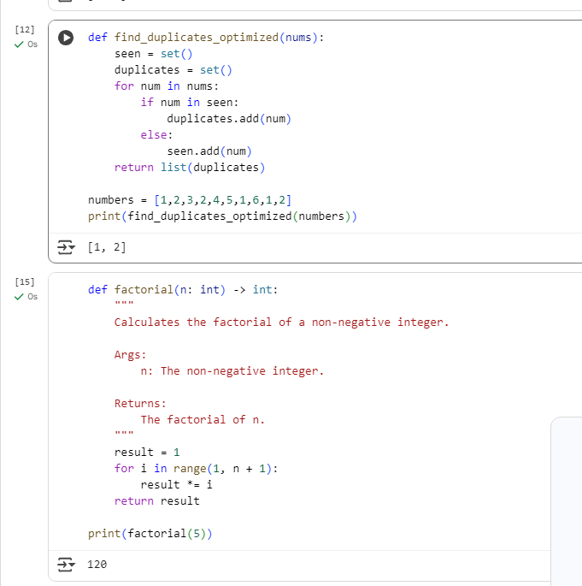

**Task 4: Security and Error Handling Enhancement**

**Task:** Add security practices and exception handling to the code.

# buggy_code_task4.py

import sqlite3

def get_user_data(user_id):

conn = sqlite3.connect("users.db")

cursor = conn.cursor()

query = f"SELECT * FROM users WHERE id = {user_id};" # Potential SQL injection risk

cursor.execute(query)

result = cursor.fetchall()

conn.close()

return result

user_input = input("Enter user ID: ")

print(get_user_data(user_input))

**Expected Output:**

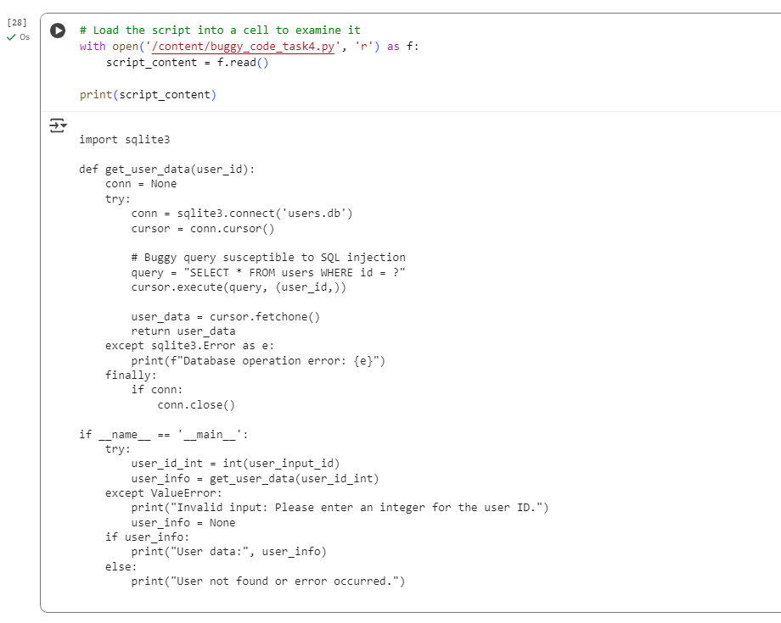

**Task 5: Automated Code Review Report Generation**

**Task**: Generate a **review report** for this messy code.

# buggy_code_task5.py

def calc(x,y,z):

if z=="add":

return x+y

elif z=="sub": return x-y

elif z=="mul":

return x*y

elif z=="div":

return x/y

else: print("wrong")

print(calc(10,5,"add"))

print(calc(10,0,"div"))

**Expected Output**:

